Mrs. Morgan’s  Student  News |  | 

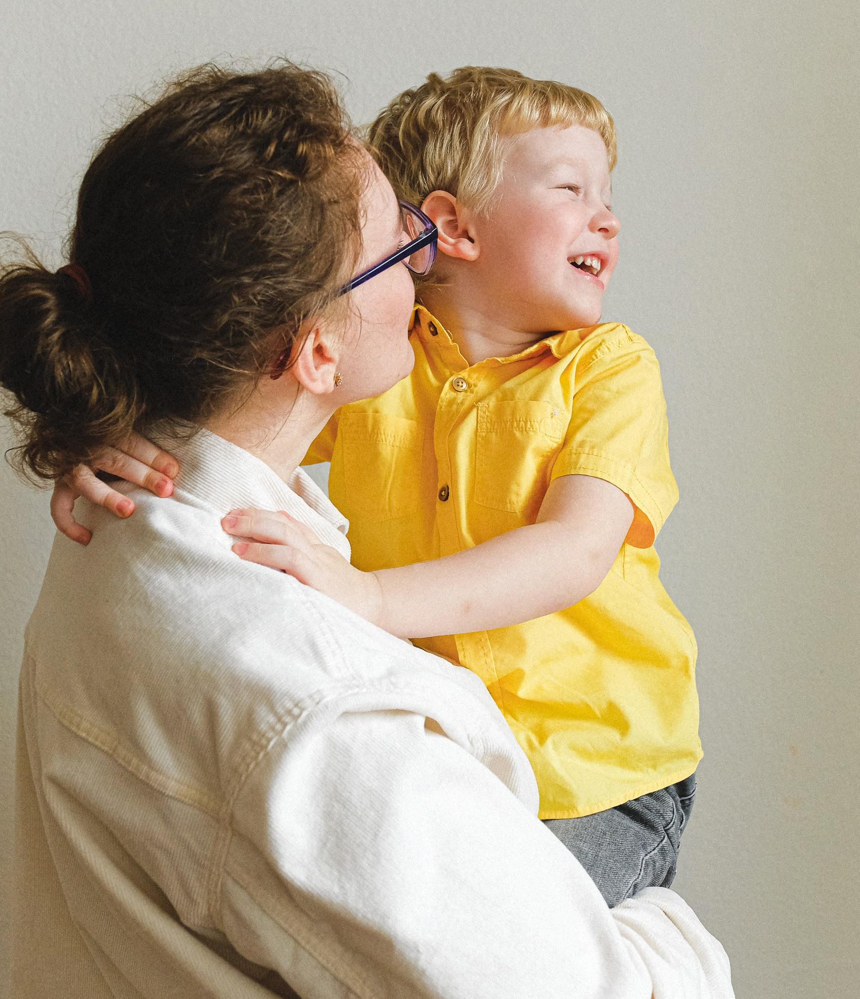 | News for the week of September 7, 2026  HOMEWORK:  Reading: 20 minutes per night  Spelling Words: memorable, seafaring, outcast, roaming, yearning, tidal, shortage, condition, betrayed, horrified
WI
 | Content Standards for the Week:  READING: Stormalong (tall tale)  (SKILLS): Text Structure (review)  MATH: patterns in numbers
 | Other Communication:  Graded work will come home on Fridays (or whatever day is at the end of the week). Please check for any papers that say “fix” on them. Your child can fix them for a better grade.  September  (7) No School  (10) Spirit Day $1/Food  (14) Fall Pictures  (17) Chocolate Sales end  (18) No School  (21) Faith Families  ***Nonfiction Text Features due September 14th***  PLEASE HAVE YOUR CHILD BRING A WATER BOTTLE EVERY DAY ALL YEAR!!

